【重点考点一】特殊疑问词Who/Which：通常放在句首1＞Who，谁询问人的身份、姓名
如：—Who is that girl?
—She is my sister.
—Who is she?—She is Alice.
2＞Which，哪一个；哪一些可用来提问人、物
如：—Which woman is your mother? —The woman with a bag is my mother.
—Which do you like, apples or grapes? —I like apples.
【重点考点二】man的复数：menwoman的复数：women如：There are some women and a man over there.那儿有一些妇女和一位男士。
同理：
policeman的复数：policemenpolicewoman的复数：：policewomen如：
There is a policeman over there.那儿有一个警察。
【重点考点三】one的用法1＞作代词替代具体的“一个人”或“一个事物”，指代可数名词单数，避免重复。既可指人，也可指物。复数形式为ones如：There are two books on the desk.The red one is Tom's.书桌上有两本书，红色的那本是Tom的。
(one在这里是代词，指代前面的book)
2＞作数词，表示一个/只...如：I have one toy car.我有一辆玩具汽车。(one在这里是数词，表示一辆)

【重点考点四】in/with/wear在表达穿戴上的辨析：■① in，介词，后接衣物/颜色侧重衣服的款式、颜色如：My brother is in a blue jacket.我弟弟穿着一件蓝色夹克。
The man in blue is a worker.
穿蓝色衣服的男士是一位工人。
■② with，介词，后接眼镜/手套等强调佩饰如：The man with glasses is my father.戴眼镜的男士是我父亲。
另外，with可表示带有/伴随某种特征如：The woman with a baby is my aunt.
带着一个婴儿的妇女是我姑妈。He is a tall man with short hair.他是一个有着短发的高个男人。
■③wear，实义动词，有时态变化前面一般有主语，后须接衣物作宾语强调穿的状态意为“穿着（制服、牛仔裤、鞋子等）；戴着（帽子、眼镜等）；围着（围巾等）
如：I often wear a yellow coat in winter.冬天我经常穿着一件黄色大衣。
She wears a red scarf.她围着一条红色围巾。
■④总结：in+颜色/衣物（in无时态变化）with+佩饰/特征（with无时态变化）主语+wear+衣物（wear有时态变化）

【重点考点五】look like: 看起来像...look表示“看” ，是动词，有时态变化； like表示“像” ，是介词，无时态变化如：He looks like a cook.（主语he是三单，look加s变为动词三单）
You look like a policeman. （主语You不是三单，look不变）
【拓展】相关句型变换：1＞肯定句：She looks like a teacher.
2＞否定句：She doesn't look like a teacher.
3＞一般疑问句：Does she look like a teacher?
4＞特殊疑问句: —What does she look like ?—She looks like a teacher.
【重点考点六】书本P4部分精讲
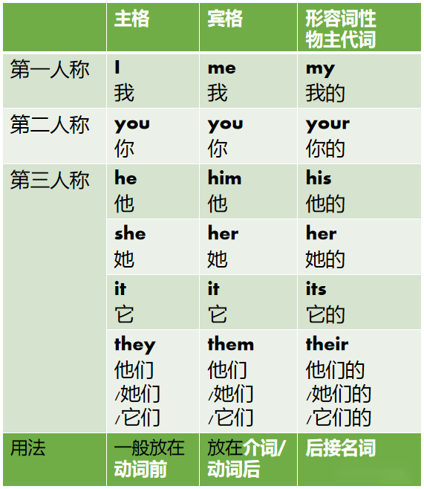
1＞主格用作主语，放在动词前如：He is a teacher.
主格是He，放在be动词(is)前
They have some toys.
主格是They，放在实义动词(have)前
2＞宾格用作宾语，放在介词/动词后如：The bag is beside her.
her是宾格，放在介词beside后
Can you see him?him是宾格，放在动词see后
3＞形容词性物主代词（简称：形物代），后须接名词如：Ms White is our teacher.our是形物代，后接名词teacher
This is my book.my是形物代，后接名词book
【重点考点七】
like的用法
1＞作动词，表示喜欢
例：
We like reading books in the library.
我们喜欢在图书馆看书。

2＞作介词，表示像，怎么样
例：
Life is like a box of chocolate.
生活就像一盒巧克力。

